LAB 6 Assignment

Shuaiyu Liang (sl5352)

Tuesday 20th October, 2015

1-2. The source code for question 1-2 is in the package named Lab_6_Sec1_Ex2_sl5352.py

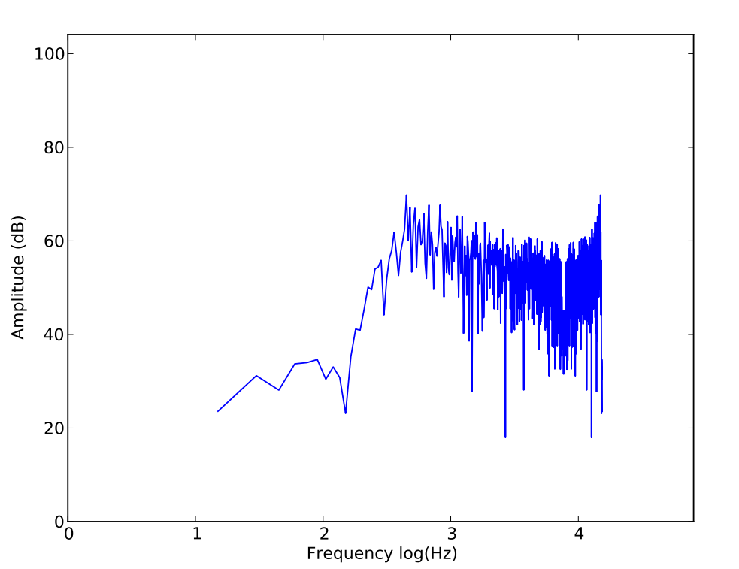

The real time plot is shown above. When run the code for first question, it will generate pdf file automatically to the current folder.

2-3. The source code for question 2-3 is in the package named Lab_6_Sec2_Ex3_sl5352.py

This time, the signal output after amplitude modulation is much clearer than last time.

3-1. The source code for question 3-1 is in the package named Lab_6_Sec3_Ex1_sl5352.py

I plot three different situations. That is one piercing balloon in a small room, one piercing balloon in a large room, which could be think as record outside. One is human sound. The impulse response is shown as fallow:

Big room, pierce balloon: Small room, pierce balloon:

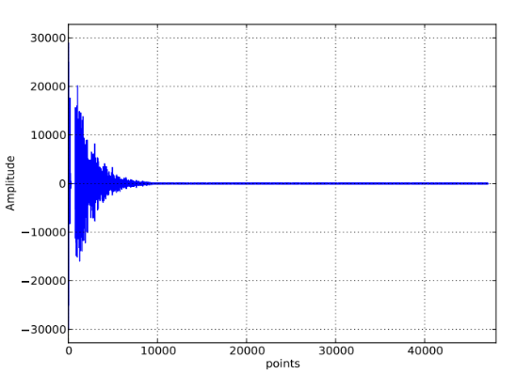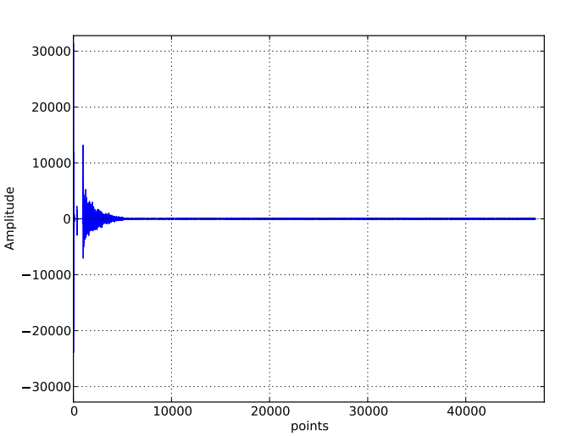

Could tell those differences:

Initial sound amplitude.

Decaying time

And finally test my human sound in big room. Kind of same decaying time and much higher initial amplitude cause I really made a big noise.

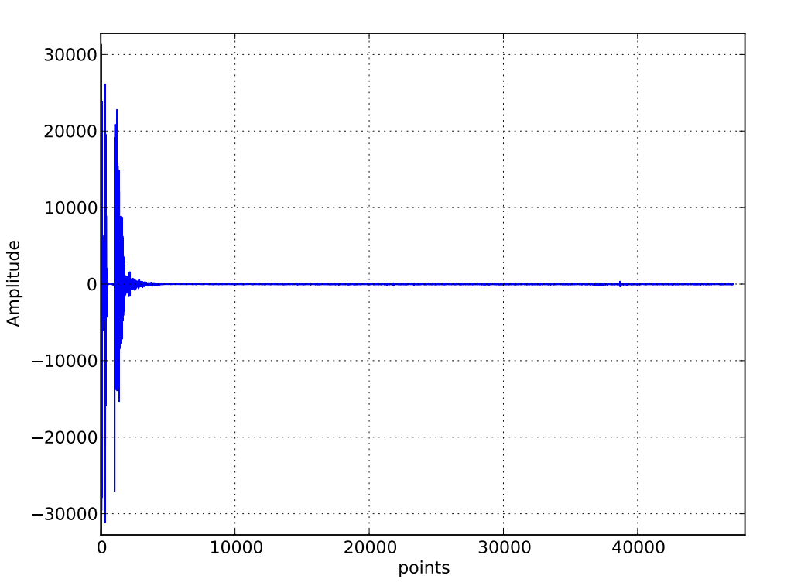

When running the 3rd question’s code, these plot will be automatically generated. The audio recording will be restored in the current directory.